Homework 2

Start of Report

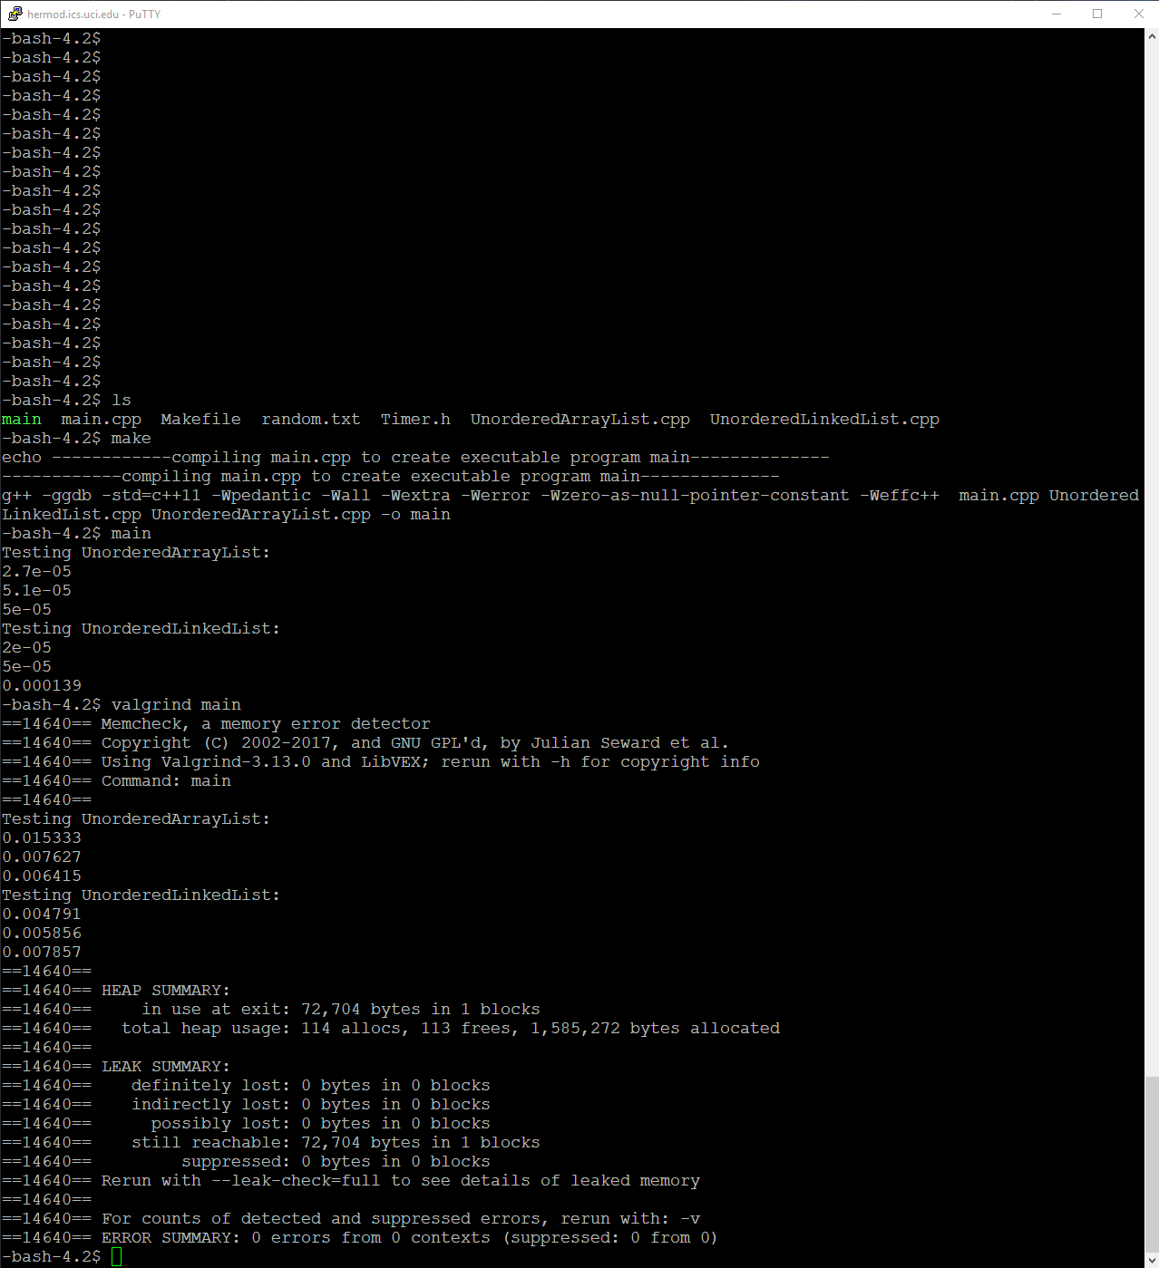

Files in directory followed by a normal run of the program followed by a valgrind run of the program. Random.txt only has like 100 words.

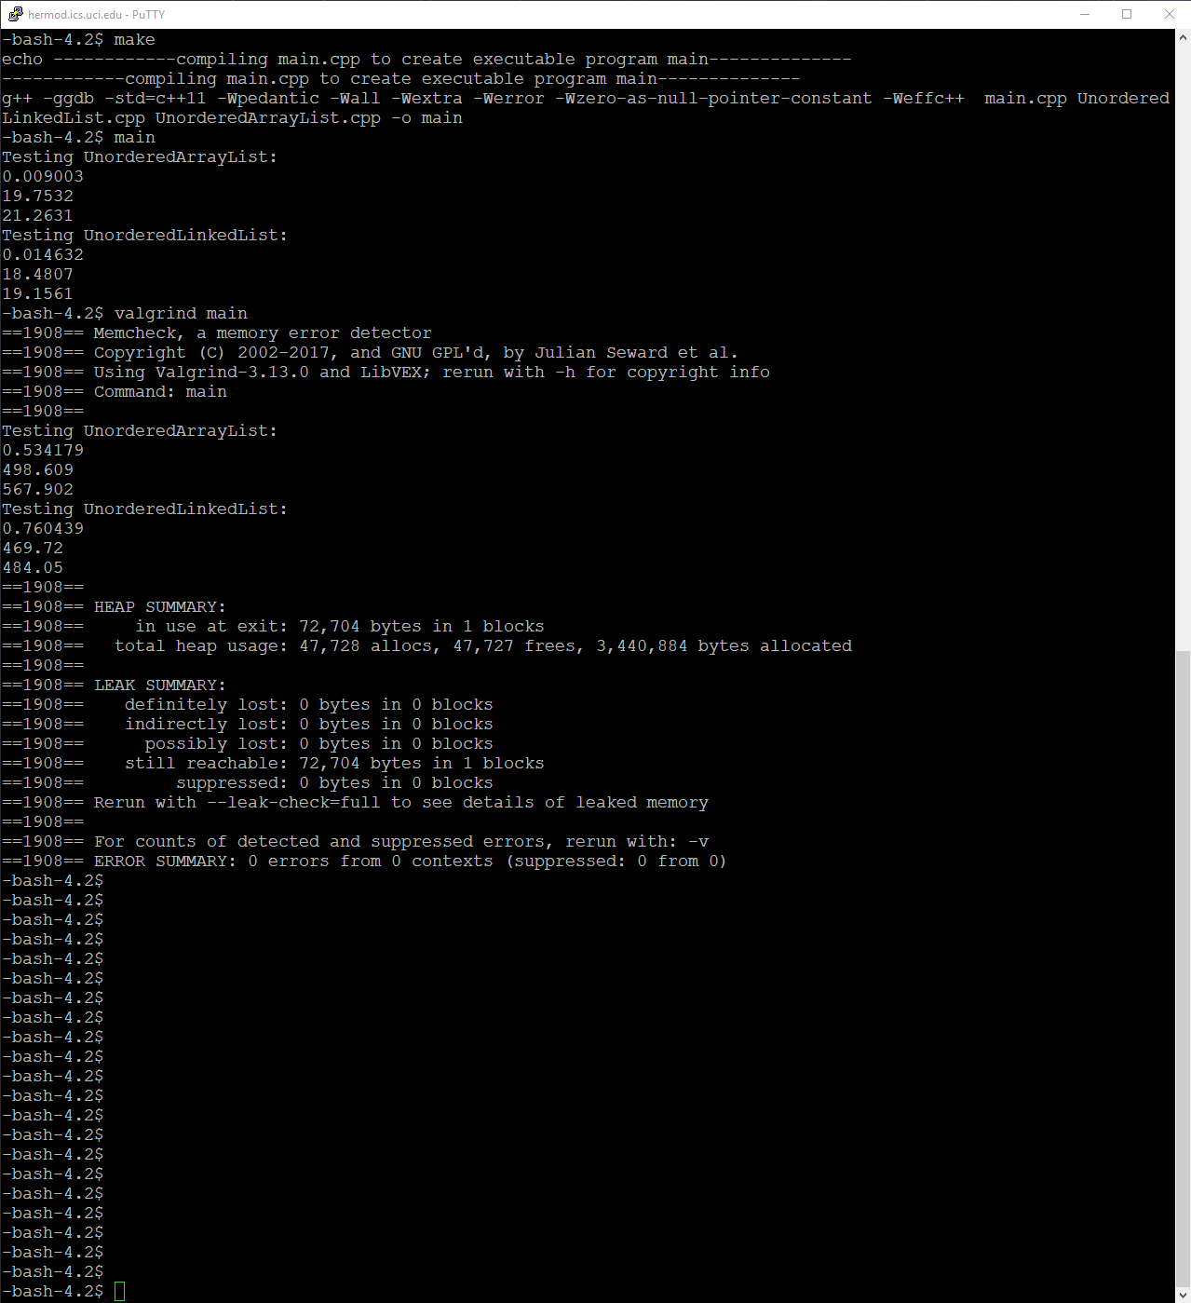

Here is my out put of a normal run with valgrind as well using ~45,000 words.

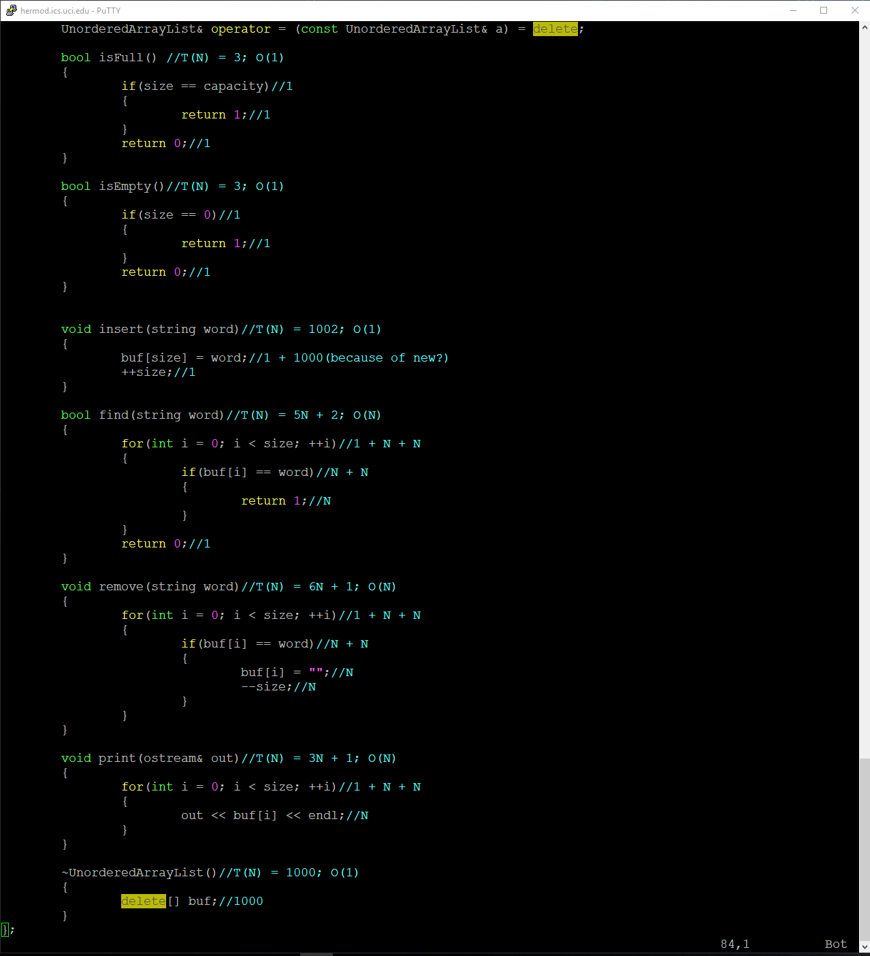

Here is O(N) for the ArrayList methods. I wrote the T(N) to help me but O(N) is followed by that on the same line.

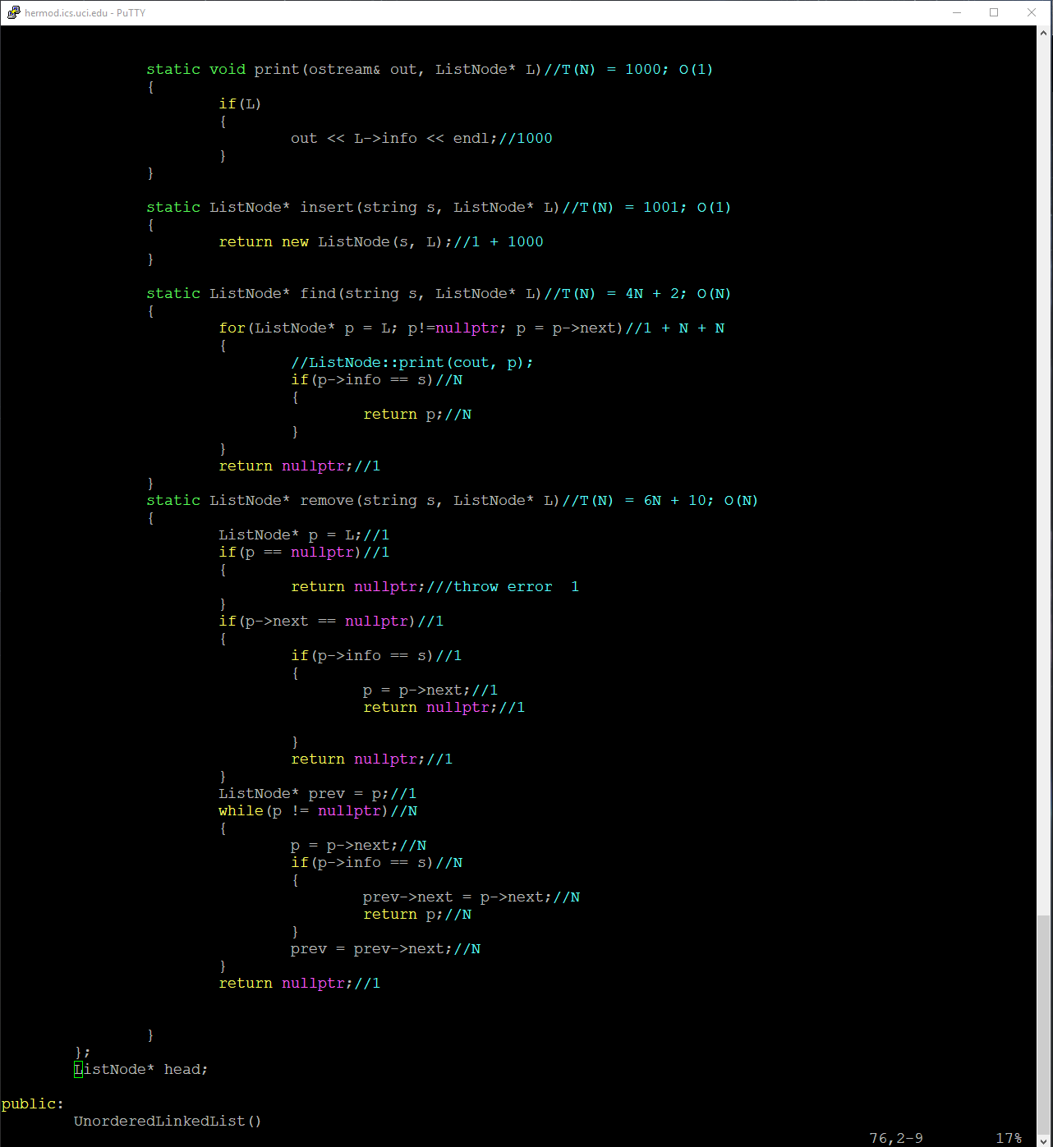

Here is the O(N) for the static functions in the Linked List class. I wrote the T(N) to help me but O(N) is followed by that on the same line.

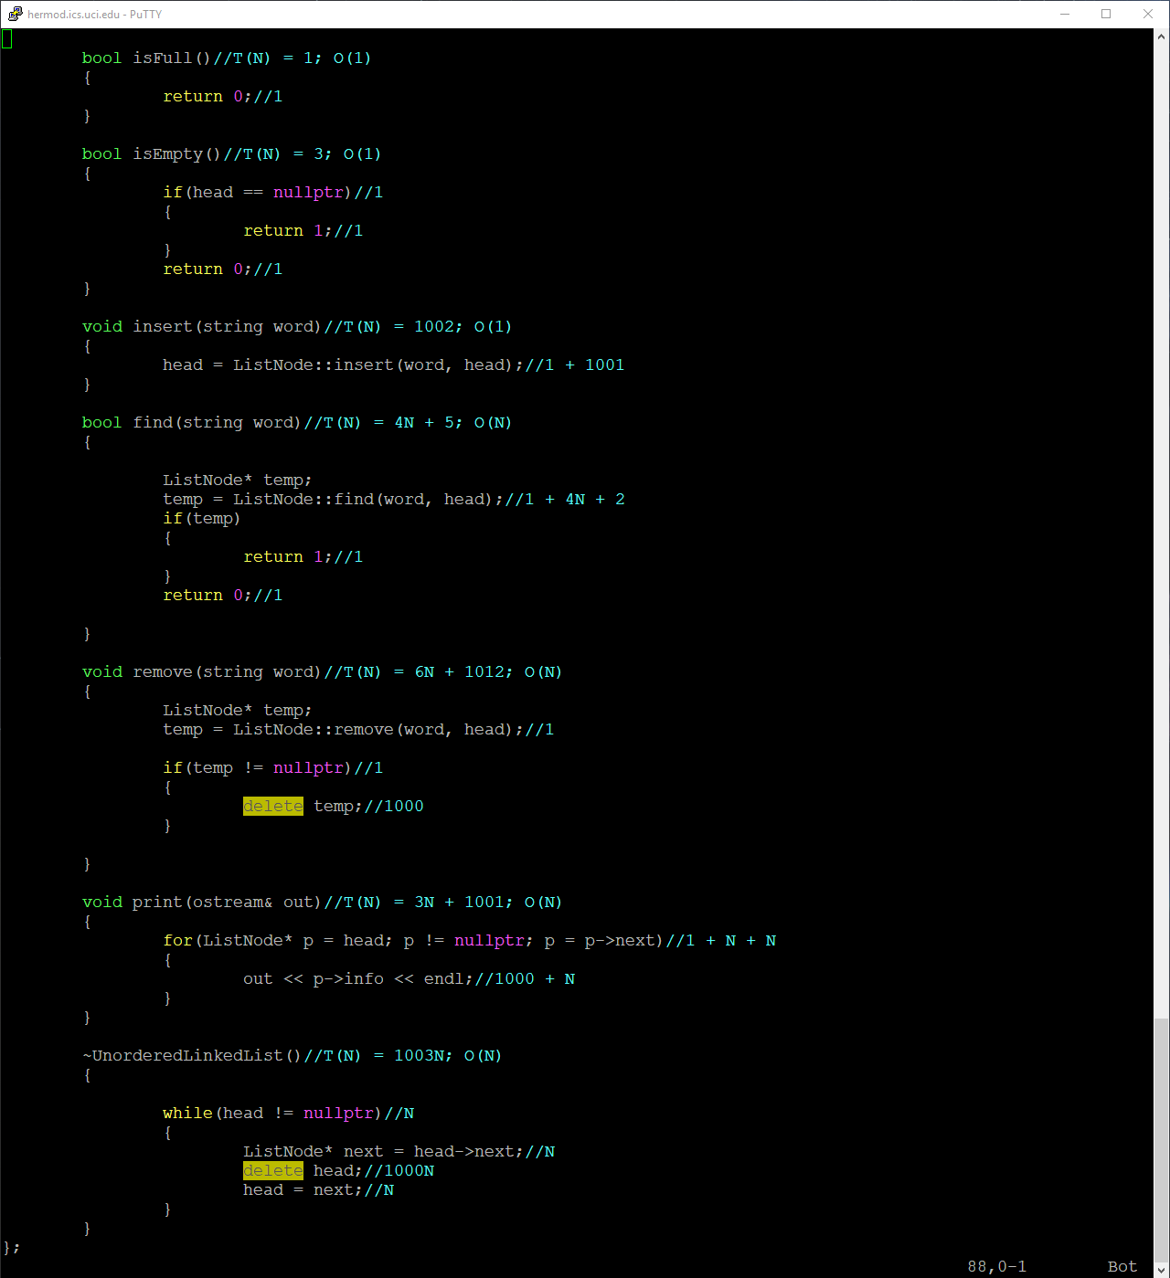

Here are the methods for the Linked List class. I wrote the T(N) to help me but O(N) is followed by that on the same line.

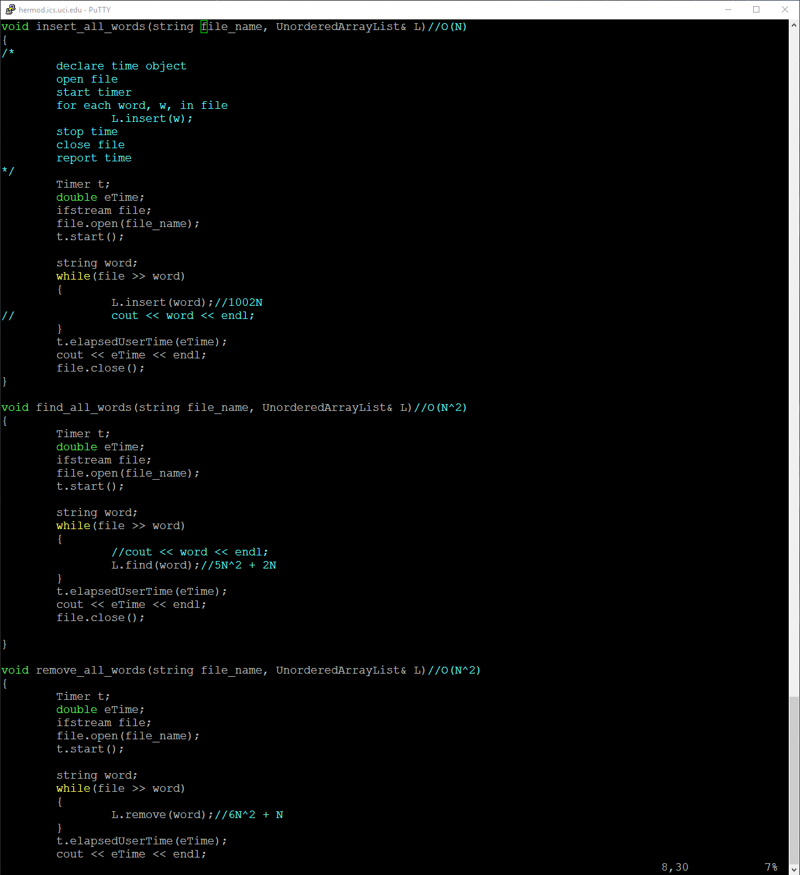

Here is the O(N) for the test functions of Array List.

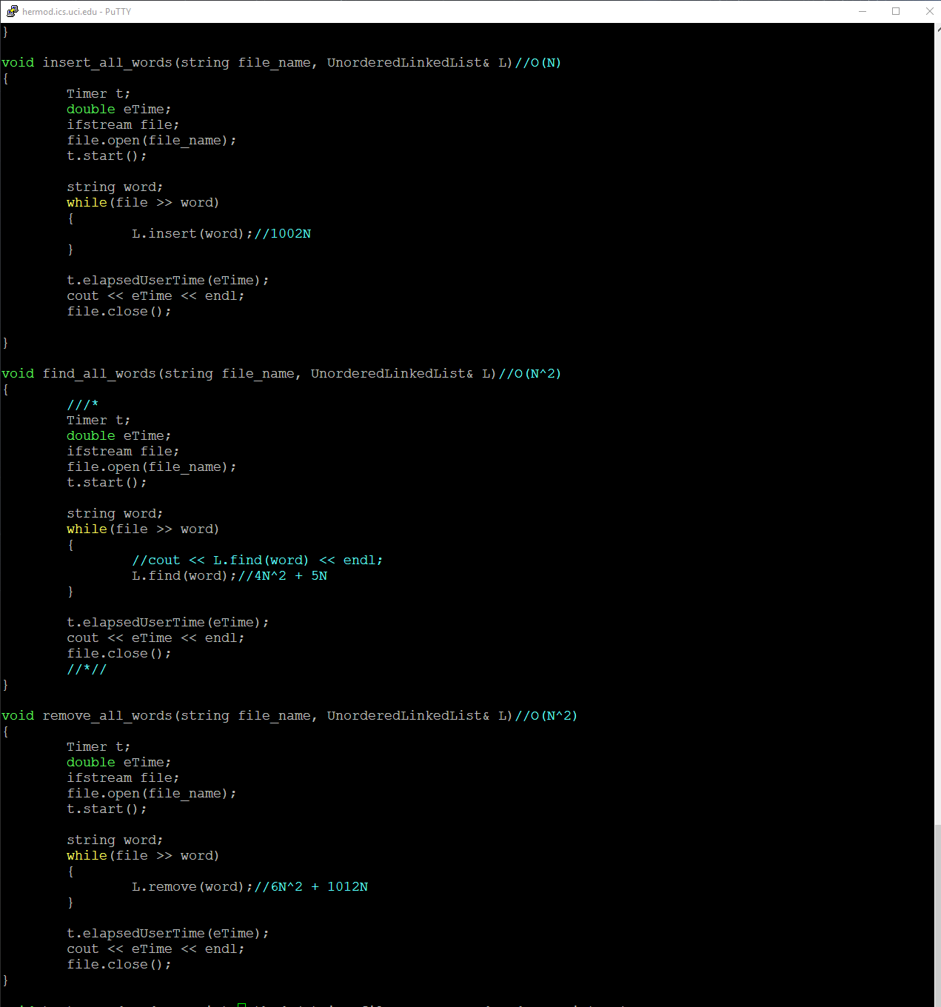

Here is the O(N) for the test functions of Array List.

End of Report